**Question 1**

A) Item is the 5 easiest - item 10 is the hardest.

B) -1.885441 -1.367981. It means that the item can vary between -1.885441 and -1.367981.

C) 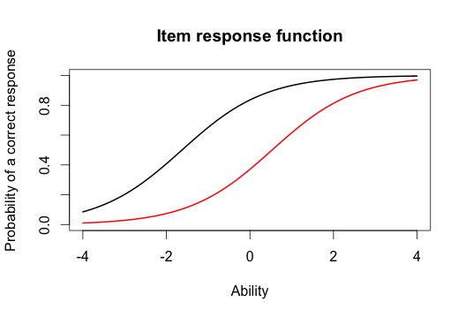

D) 0,4 (red) and 0,8 (black)

E) Min -3.999947 (worst) Max 3.999921 (best)

F) 8.320492 -0.3206501, it means that the ability for the person that did best on the test varied between 8.320492 and -0.3206501.

**Question 2**

A) 1, 3, 5

B)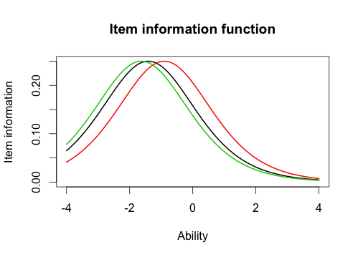

C) The curve is the same but the location of the curve is not the same. (The item information is the same but the ability is not the same.)

D)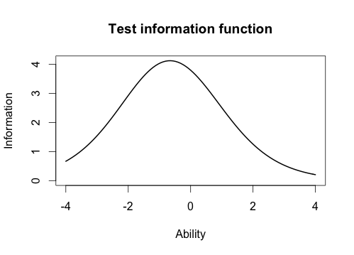

E) Between -1 and 0.

**Question 3**

A) Item 8 had the highest, item 12 had the lowest.

B) No they are not the same.

C) 0.9709497, I would say that they are highly correlated, 0.97 is a very high correlation. I would probably draw the same conclusion from both models because they are so highly correlated.

D)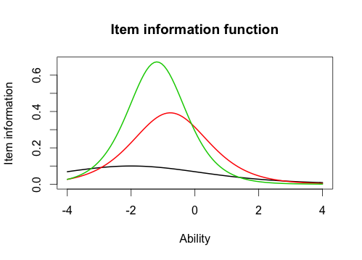

E) Their curves are not the same. In the Rasch model their curves were the same.

Black has the lowest discrimination, green has the highest discrimination.